**diana's work log**

**11/11/2024**

Can you change the photo cover on this CantoVario video (I look like I’m about to cry :)

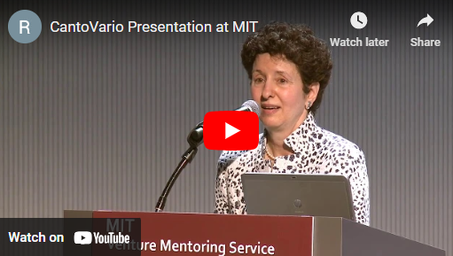

How do I get a long dash in the html code, i.e., — , as in … engineering—by …

**10/28/2024**

?: when I make chgs to index.html and then make chgs to about.html, can I just push the chgs from the VS code w my cursor in index.html? It seems that also covered the chgs I made to about.html. As a test, I then went to the VS code for about.html, placed my cursor in the text there, and pushed, and got the below messages. So it appears I can just push the changes from VS code with my cursor in index.html.

Can I push the changes with my cursor placed anywhere (in any section) of the VS code?

Glitch: when hit the “here” link at bottom of Musical Works, i.e., “The scores for all these performances can be found [here.](http://127.0.0.1:5501/website-documents/supplementary-materials/music-supplementary/III-G-musical-scores-commissions.pdf)” get the msg: Cannot GET /website-documents/supplementary-materials/music-supplementary/III-G-musical-scores-commissions.pdf

The Scores can now be found in “Binder III-G dd works-Scores” PDF in GREEN folder.

Glitch: why does “DISCIPLINARY AND INTERDISCIPLINARY WORK FOR EXTERNAL IMPACT, DEVELOPING STUDENTS, BUILDING & SUSTAINING OLIN COLLEGE” occur at the bottom of the same page as “Musical Works”?

Glitch: when hit the link “[**This document**](http://127.0.0.1:5501/website-documents/supplementary-materials/music-supplementary/orchestral-arrangements/A-IV-K-3-yearly-arrangements.pdf)**—organized by academic year—gives orchestral arrangements…”, under orch-arrangements.html** get error msg: Cannot GET /website-documents/supplementary-materials/music-supplementary/III-G-musical-scores-commissions.pdf

The list of orchestral arrangements—organized by academic year can now be found in “AppIV-K-3 list of OCO Arrangements by AY” in GREEN folder.

Glitch: when hit the link “(The specific re-orchestrations mentioned below are elaborated further in [this document](http://127.0.0.1:5501/website-documents/supplementary-materials/music-supplementary/orchestral-arrangements/A-IV-K-1-orchestral-arrangements.pdf))”, get the msg: Cannot GET /website-documents/supplementary-materials/music-supplementary/orchestral-arrangements/A-IV-K-1-orchestral-arrangements.pdf

The brief analyses of eight orchestral arrangements can now be found in “AppIV-K-1 A Sampling of my Orchestral Arrangements-8 brief analyses” in GREEN folder

Glitch: when hit the link “[This document](http://127.0.0.1:5501/website-documents/supplementary-materials/music-supplementary/orchestral-arrangements/A-IV-K-1-orchestral-arrangements.pdf) examines eight of my orchestral arrangements, showing …” , get error msg: Cannot GET /website-documents/supplementary-materials/music-supplementary/orchestral-arrangements/A-IV-K-1-orchestral-arrangements.pdf.

The brief analyses of eight orchestral arrangements can now be found in “AppIV-K-1 A Sampling of my Orchestral Arrangements-8 brief analyses” in GREEN folder

Pls also add to ‘Scores’ under music-subpages: Binder III-G dd works-Scores, 8 Sample Orchestral Arrangements-SCORES in GREEN folder

**10/28/2024**

Today I finished music-subpages:

* Updated musical-works text; noted glitch (pls see above in red)
* Updated orch-arrangements, including Updated image: Role of 3 Themes in '140+ Orch Arrangements' – cropped2. The updated image is in the GREEN folder. Also, noted glitches (pls see above in red)

**10/27/2024**

1. Updated CV and added it to GREEN folder
2. Edited Home page, ‘More About Diana’, and revised ‘Curriculum Vitae’ (see PDF in GREEN folder).
3. Pushed changes to github

?’s for Suki: can you align the “Learn More” buttons at the bottom of the home page:

Can you check the alignment of the below buttons; Curriculum Vitae looks slightly higher than “More about Diana”:

